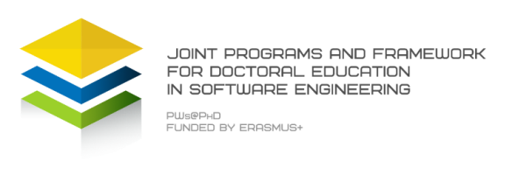 | 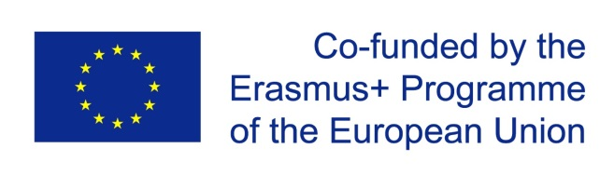
Joint Programs and Framework for doctoral education in software engineering (PWs@PhD)

Train the next generation of highly qualified academic researchers and educators in different research areas of software engineering.

Objective
Support the development, modernization and international visibility and excellence of higher education, namely education by research at the PhD level in Europe while helping also partner countries to develop new Ph.D programs and consolidate existing ones in the field of Computing, and more specifically in the area of Software Engineering

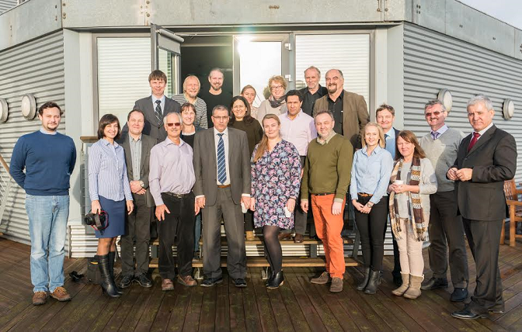
About the Project

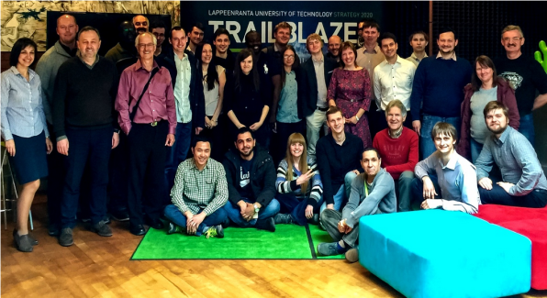
- PWs@PhD is a multi-institutions, multi-disciplinary, multi-cultural PhD project related to software engineering education in the PhD level that brings together 11 universities; 4 from EU, 4 from Russia and 3 from Jordan.

- PWs@PhD covers the key areas of knowledge described in the SWEBOK book (the Software Engineering body of Knowledge) as well as the soft skills such as technical writing, communication, collaboration in software development
الجامعات المشاركة

- PWs@PhD builds a tighter feet between scientific research theories and the industry practices, experiences needs and prioritie PWds offers to the future generation of researchers, Ph.Ds and Postdoc in Software Engineering a unique opportunity to visit different universities and countries where they can discover research labs/teams and their tradition, tools and methods for engineering complex software-intensive systems.

- The program focuses on Software Engineering discipline that has the same core as Computer Science, i.e. algorithms and mathematical foundations as an applied technology-oriented discipline. Software Engineering has also strong connections with various other disciplines as highlighted by the SWEBOK (Software Engineering Body of Knowledge).

- The program comprises 7 schools in 6 countries, more than 100 PhDs and 50 professors and research staff involved
- Each school includes training activities, research lab work, workshops, life demos, posters, industry case studies
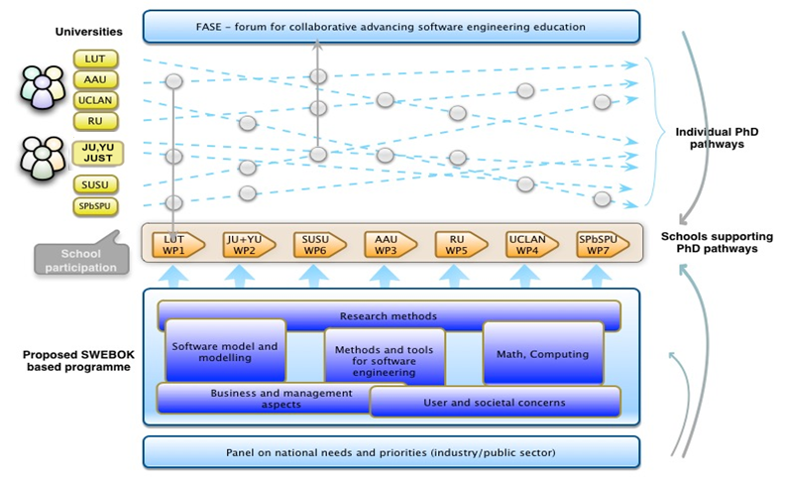
Participating Universities

 |  |  | الجامعات المشاركة
http://ju.edu.jo | http://www.yu.edu.jo/en/ | http://www.just.edu.jo | http://www.lut.fi/en/
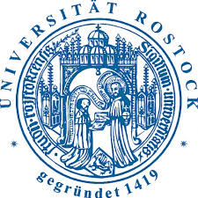 | 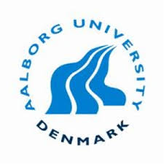
https://www.uni-rostock.de/en/ | http://www.en.aau.dk/ | http://www.uclan.ac.uk/ | https://www.susu.ru/en
 |  | 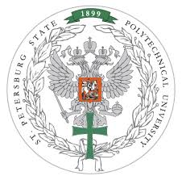
https://urfu.ru/en/ | http://english.spbu.ru/ | http://english.spbstu.ru/

